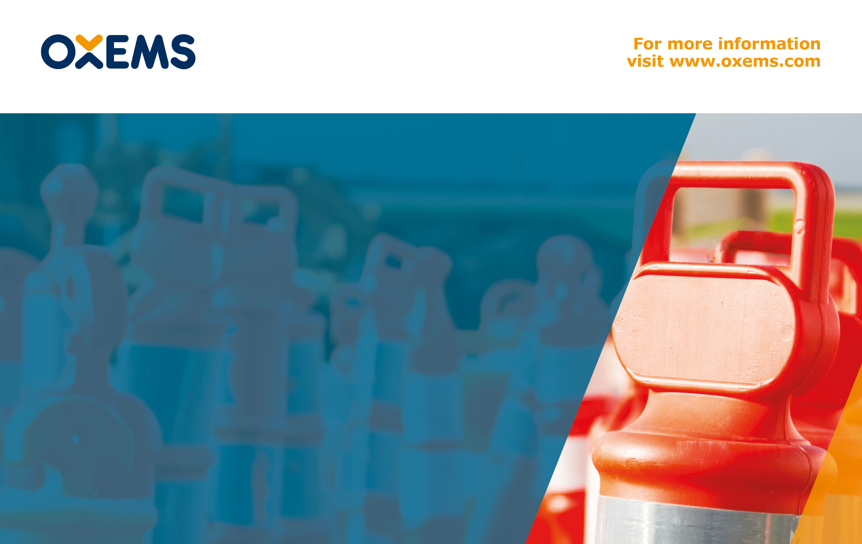
Super Detectors

OXEMS Blog
December 2014

GETTING SO MUCH MORE FROM A DETECTOR

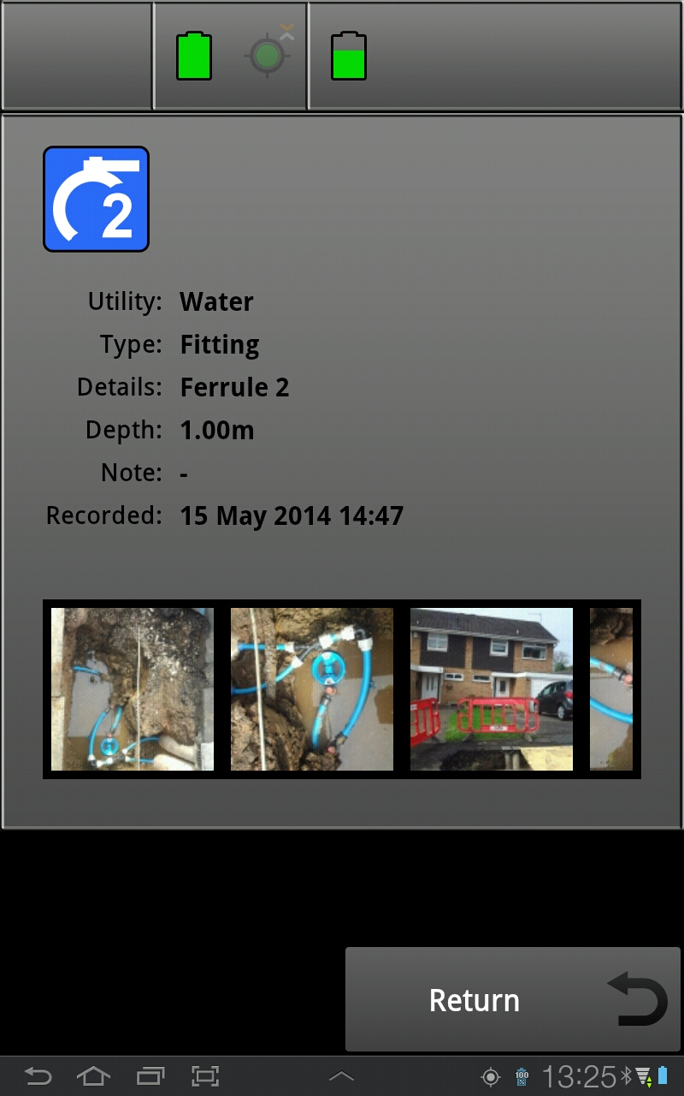
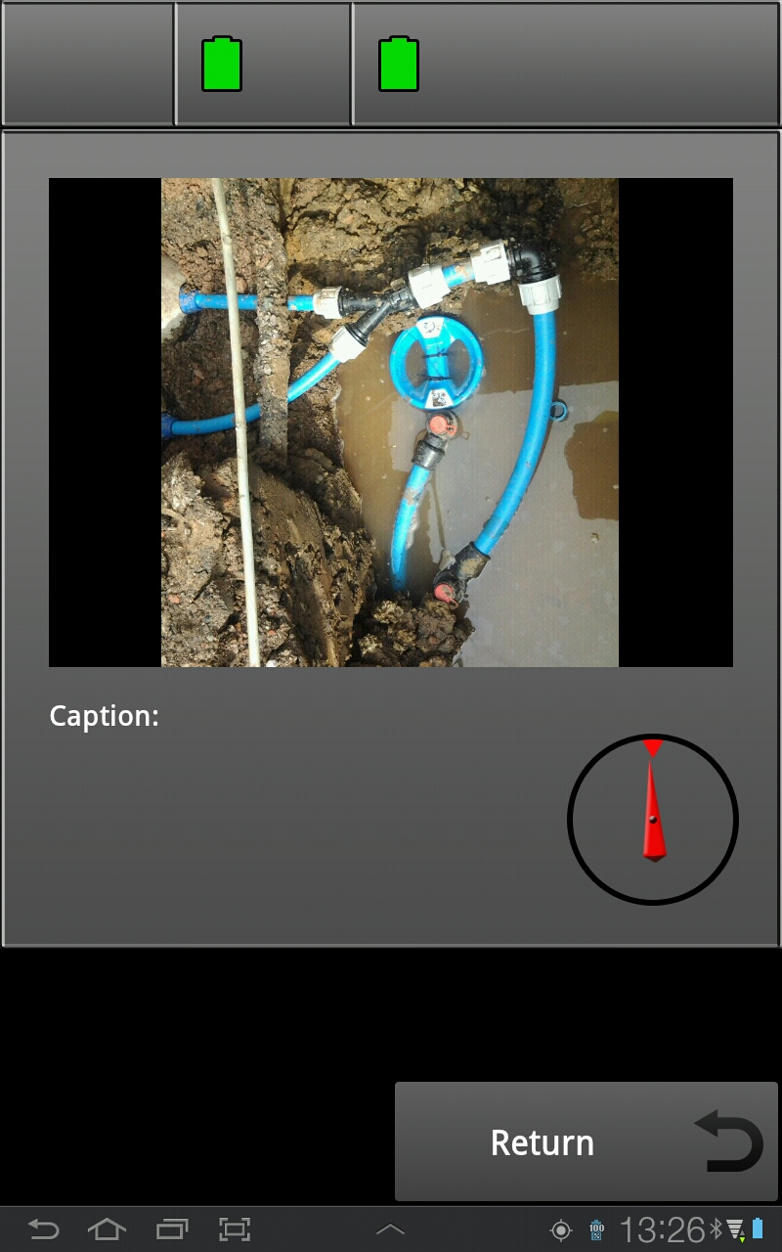
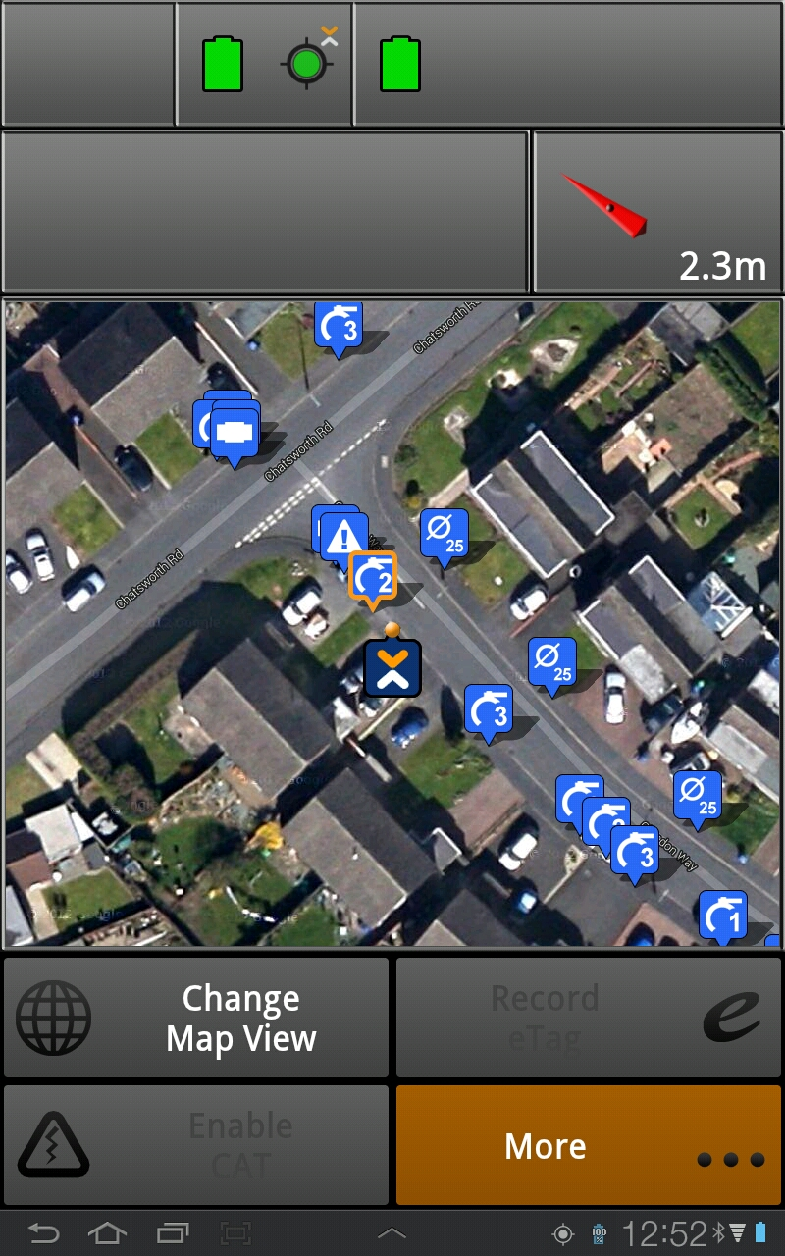

The OXEMS System for detecting underground assets – plastic or metal – works equally well for both materials. In fact we do not set out to detect metal or plastic but to re-locate a tag that is buried together with each asset. The OXEMS Detector can locate any OXEMS Tag … precisely. Not only does it locate the tag but it also shows the ground crew what type of asset the tag relates to - for example a valve – and also its depth, age and a mass of other asset-specific information.

READING AND WRITING

But the OXEMS Detector has another trick up its sleeve. As well as detecting tags and displaying information about those tagged assets, it also updates the remote database with any new information. That might comprise a new service record, new photograph, indication of depth and any other relevant information. That information instantaneously becomes available to the user on the street, displayed along with a map via an easy to use App. It doesn’t have to be collated and updated manually back at the office … it happens in an instant.

SIMPLE TO USE, INEXPENSIVE TO OPERATE

The benefits this brings to a street operator are clear. The App on its own can get them close to an asset by using standard GPS technology, then they’ll use the detector to get right over the top of it, pinpointing the tag and asset itself. At that point they can quickly check the photographs, orientation and all the data relating to the asset. For example they can see in which direction the service pipe leaves the main and see whether there are any kinks or curves in it. From the operator’s perspective it’s not rocket science. If they can use a smart phone and satnav then they are halfway there already. It’s designed to be simple and easy to use and inexpensive to deploy and operate.

What more could utility companies want?

This Blog was first published in December, 2014

To receive carefully selected relevant information, and to stay informed about OXEMS,
please go to www.oxems.com and provide your contact details.

