The Day I Joined
a Gang

OXEMS Blog
May 2014

YO FROM THE STREET!
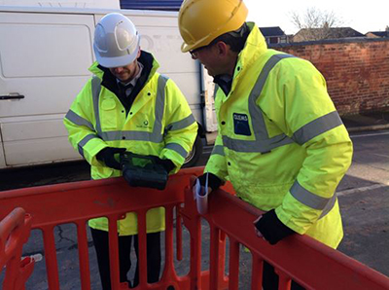
Don’t worry, that’s as far as my street cred goes. Anyway I’m talking about a utility company gang – those who are tasked with digging up our streets to locate the buried assets that the utilities have buried everywhere beneath our feet. Water, gas, electricity, telecoms. In fact anything and everything that goes in and out of your house without using the front door.

IMPROVING THE UTILITIES' BUSIENSS

I can learn more spending a day with a utility gang than in a month with an industry expert – try it! Admittedly you are going to learn a different knowledge set but one that is equally relevant to running a utility service successfully. Over the years I’ve accumulated quite a lot of utility related knowledge as CEO at OXEMS, after all we are in business to help improve the utilities’ businesses, each and every one of them.

LUCKY NUMBERS

So I went along to see how easy it is to locate a gas service pipe in a residential street somewhere in Cambridge. A gang was tasked with locating each gas service pipe in the street. Now this might sound like a stupid question to ask a gang but believe me it wasn’t: how do you locate each service pipe? The answer I got from the crew told a story in itself. In the particular street we were in, most of the service pipes seemed to fall in perpendicular line to the gateposts.

It hadn’t taken too long for the street crew to ascertain the ‘gatepost’ pattern of pipe laying in that street but was their method scientific? Infallible? No. Without a map that was accurate or as-laid plans to hand due to the age of the infrastructure, they had turned their considerable expertise to best advantage and were locating most of the pipes quickly. They were saving the utility company the expense of bringing in GPR specialists or GPS surveyors. When I asked my next stupid question: What happens in the next few streets? The answer was that they wouldn’t know till they got there, although they already knew that the houses there were not laid out on such nice straight lines and worryingly there were no gateposts. Today they admitted, they’d been lucky.

It may sound a bit harsh and as much as I admire them, I’d love the gangs to pack their luck and intuition back into the truck and for them to pull out some scientific, infallible OXEMS technology instead.

This Blog was first published on May 7, 2014

To receive carefully selected relevant information, and to stay informed about OXEMS,
please go to www.oxems.com and provide your contact details.

