Utility Pipes go all
Kinky

OXEMS Blog
October 2014
SERVICE PIPES ARE ANYTHING BUT STRAIGHT THESE DAYS

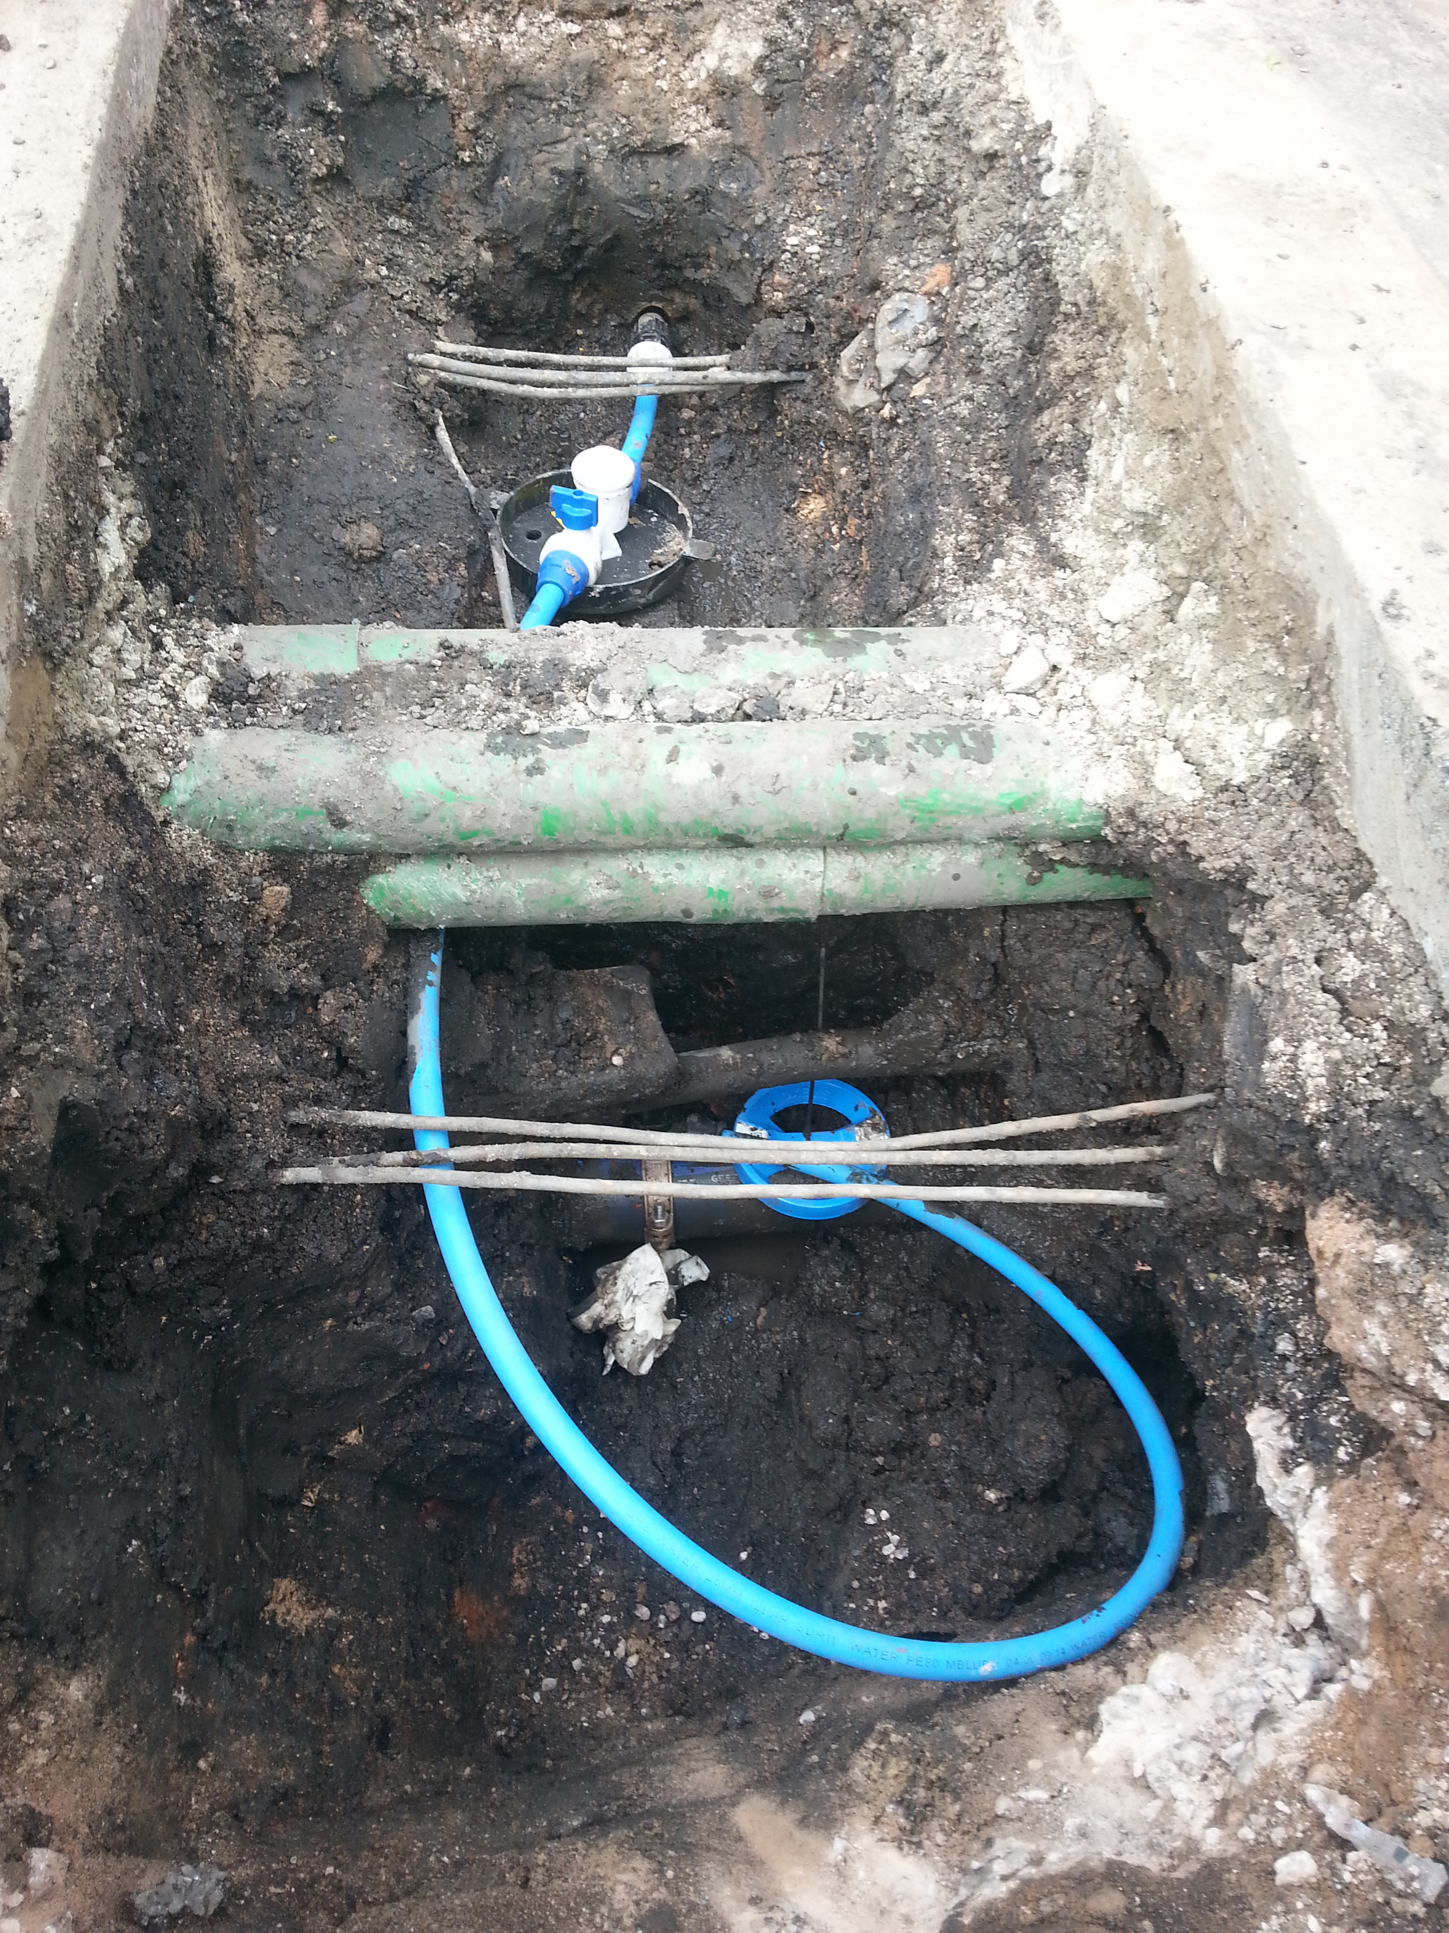
I naïvely assumed when I started in this business, that the pipe running from the water main in my street and into my home, would lie at a 90° from the main and go straight into my house in an orderly fashion. How wrong could I have been?

Of course it may well be that when a brand new housing estate is being constructed on a new site that they run the pipes in such a fashion, but everywhere else seems to vary from street to street. In fact I have seen photographs where brand new service pipes have been connected to water mains that seem to go in a spiral. Why is that? It’s because most of these new pipes are plastic and come off a giant roll and so have a natural kink as they are unwound. So pipes do not necessarily travel in a straight line these days even if they want to. This makes tracking and plotting their direction doubly difficult, as the angles that they take can be in any direction – even circular!
ROUND AND ROUND IN CIRCLES

I was recently with a water utility’s gang as they repaired a customer’s water connection. Through no fault of their own they ended up digging round in circles. That’s because along with the old metal pipe there was newer plastic pipe that actually went round in a four-metre loop before entering the house! To the gang concerned it was all in a day's work and nothing they hadn’t seen a thousand times before, but to me it demonstrated a costly frustration for all concerned with a lot of head scratching and a lot of digging.

DIGITAL RECORDS

Worryingly there was absolutely no record of how the pipes lay. Relatively new pipe work but absolutely no record of the contrary nature of the pipe lay! Until that is, we came along and deployed OXEMS technology to mark the end of all such problems. Never again will a gang arrive at that address without having sight of photographic records of how the pipes are laid, of where the joints are, of who carried out the work and much, much more. It will save the next gang hours, the utilities company a lot of money and the customer a lot of noise, dirt and frustration.

This Blog was first published in October, 2014

To receive carefully selected relevant information, and to stay informed about OXEMS,
please go to www.oxems.com and provide your contact details.

