When Ground Penetrating
Radar becomes a Distant Memory
OXEMS Blog
June 2014
SOMETHING TO BANG ON ABOUT

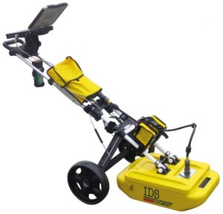
I’m always banging on about how OXEMS can deliver exceptional efficiency and effectiveness to utility companies who are tasked with locating and identifying underground assets. But today I’m going to look at ground penetrating radar - it may be expensive and require well-trained, experienced operators, but utilities resort to it in order to try to get a clear picture of what lies beneath the surface.

IDENTIFYING AN UNDERGROUND ASSET

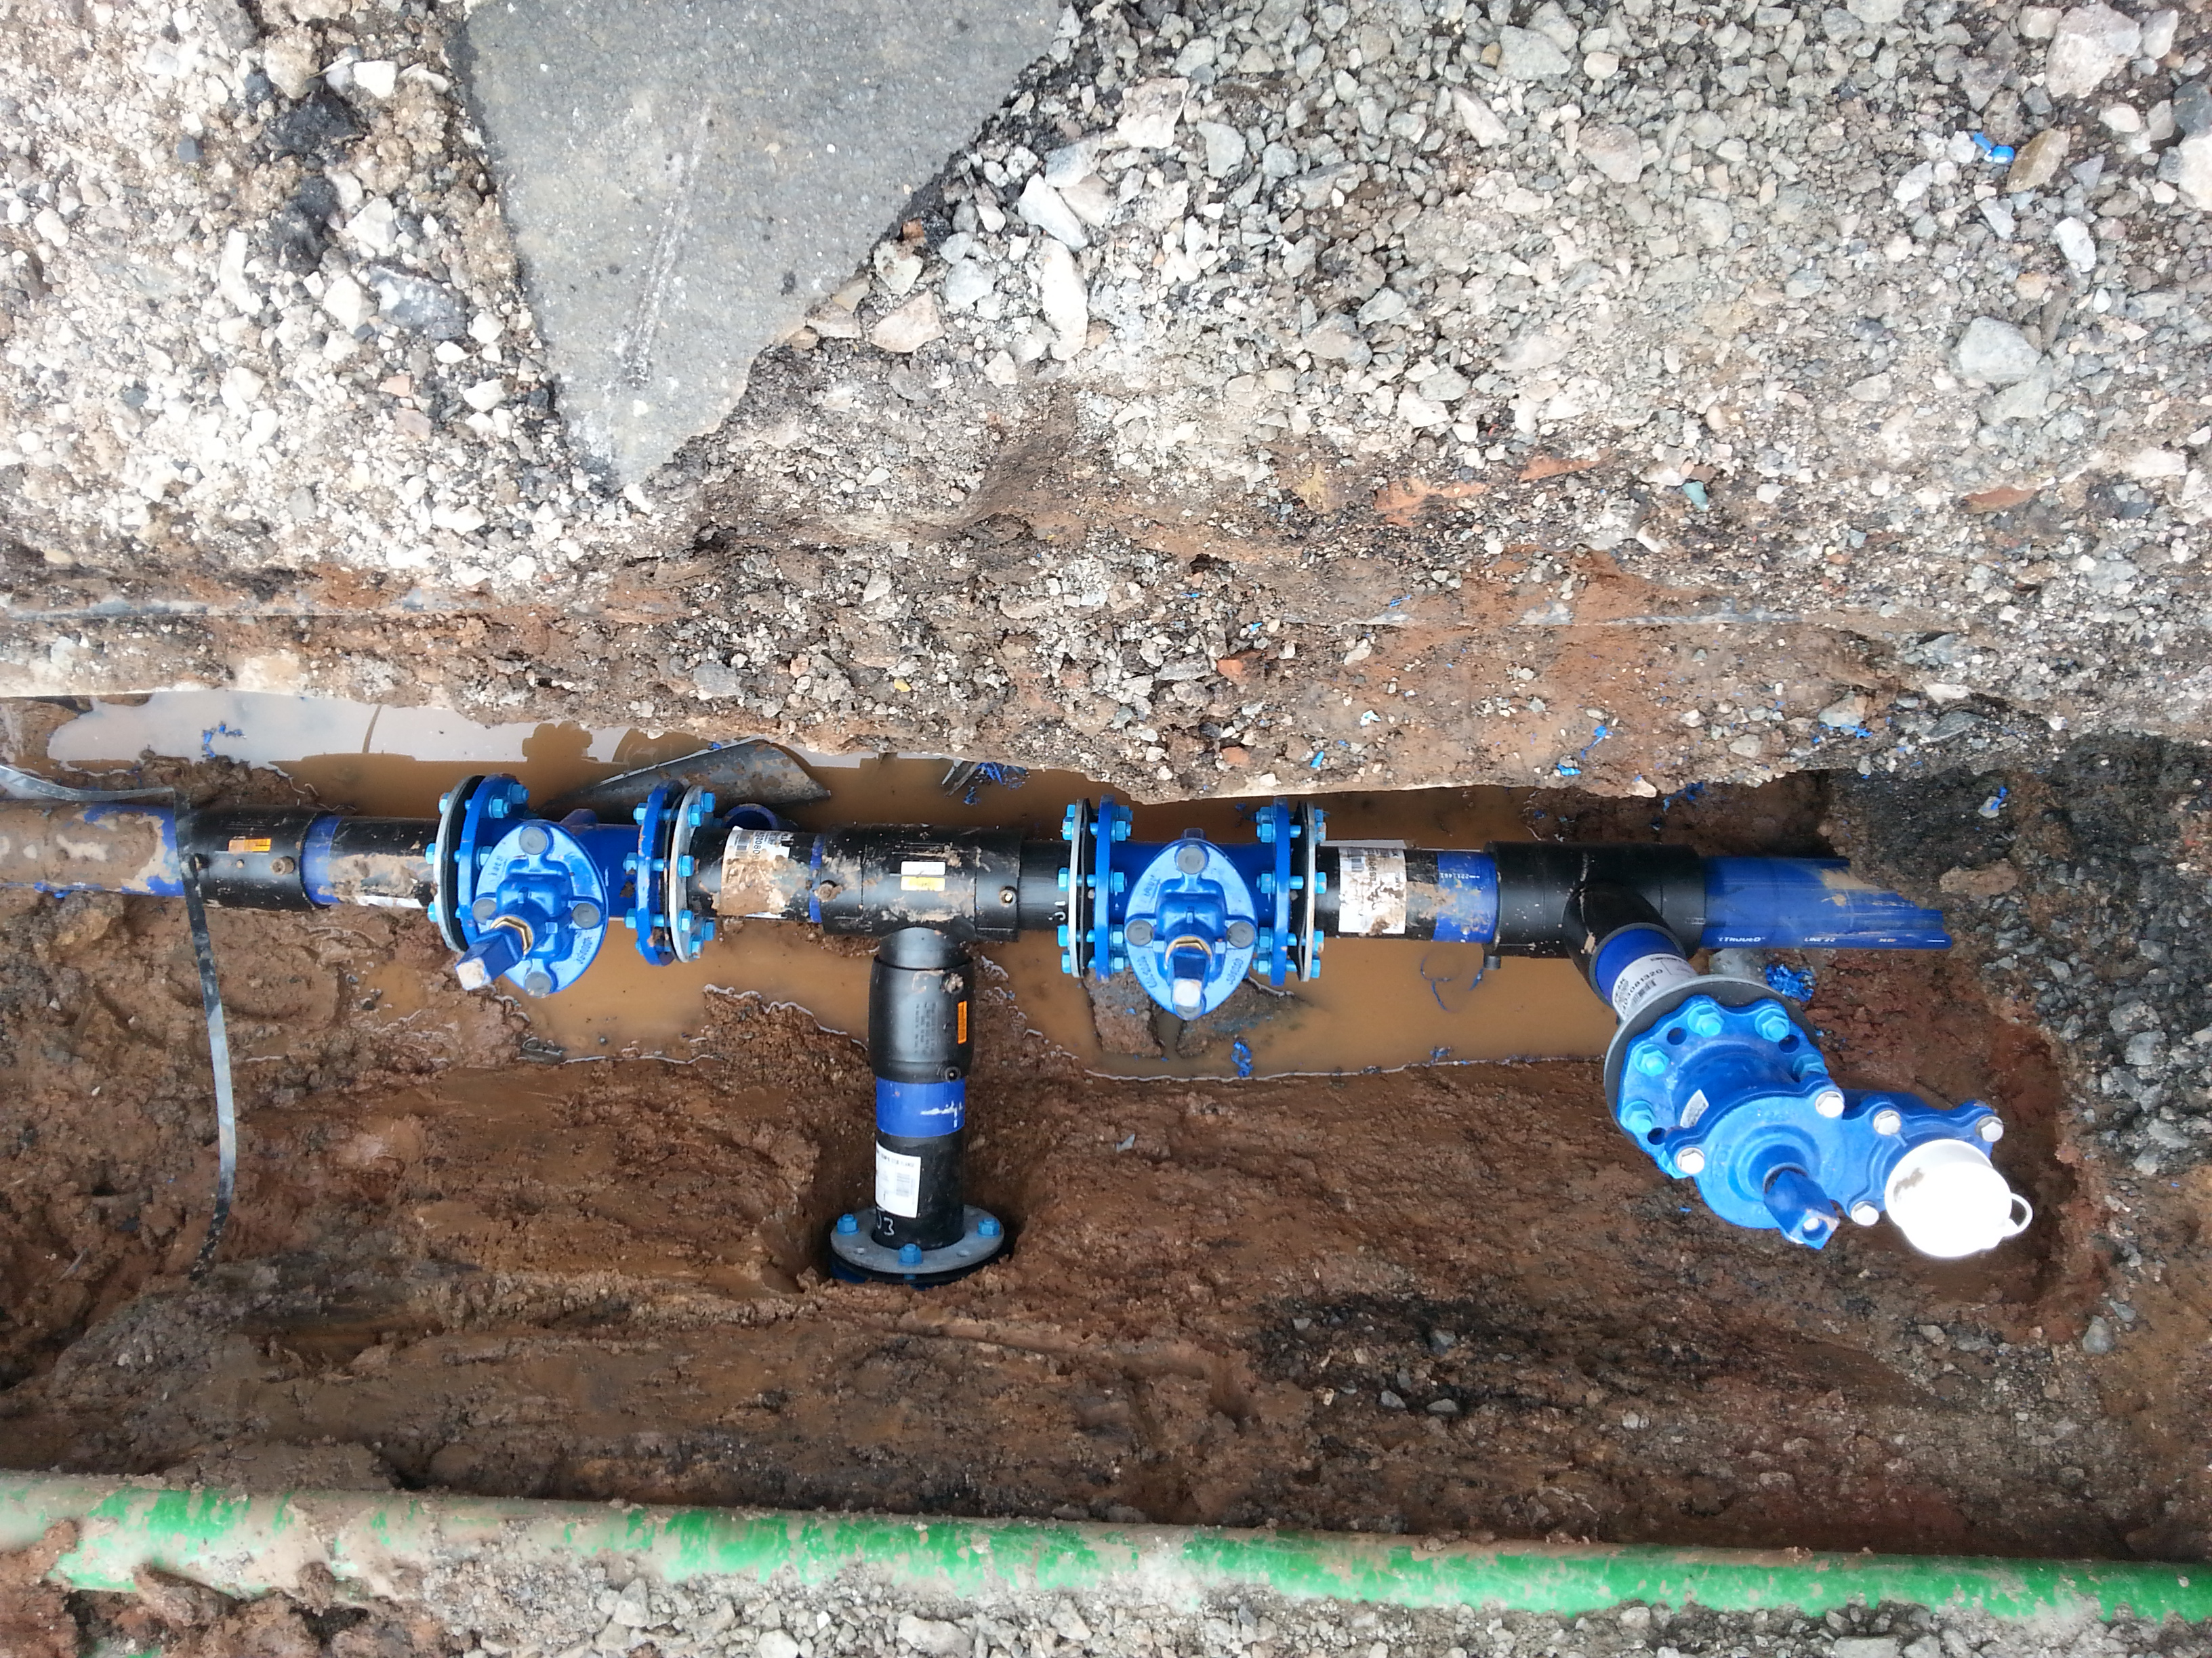
Ground penetrating radar is good to a certain extent but you really need to know what you are doing with it or it’ll eat up a lot of time and resources. Put simply it creates an impression of what is buried underground. Not a photo like you’d get with OXEMS but an outline image. The operator will use their experience to judge whether they are looking at an obstacle like a rock or steel bar, or if they are looking at a pipe.

It’s likely that ground penetrating radar will be used to survey a whole street or re-development area, in which case a considerable amount of time and budget will have to be allocated to it. So although it is not suited to getting a rapid solution or a quick understanding of what is down there, that kind of equipment will eventually yield a detailed analysis of everything which lies in a particular, well defined area. In those cases ground-penetrating radar will be used to scan East-West and North-South until the whole area is covered. Then they will take all that data away, process it, crunch it, and come up with a good image of what is happening under the ground. But it is a long-winded process and not inexpensive.

TAGGING THE FUTURE

It may well be that such terrain has remained unexcavated in living memory and there is no mapping information available anywhere. In these cases OXEMS Tags should be deployed as soon as groundwork commences. By tagging all the assets, there will be no need to use ground-penetrating radar at any time in the future.

In fact through simple OXEMS Tagging, the utility companies tasked with locating and identifying underground assets will have invested in the most effective, comprehensive and cost efficient system – and that is something worth banging on about!

This Blog was first published in July, 2014

To receive carefully selected relevant information, and to stay informed about OXEMS,
please go to www.oxems.com and provide your contact details.

